Name:B.sneha

RegNO:192111439

Question 1) Suppose that the data for analysis includes the attribute age. The age values for the data tuples are (in increasing order) 13, 15, 16, 16, 19, 20, 20, 21, 22, 22, 25, 25, 25, 25, 30, 33, 33, 35, 35, 35, 35, 36, 40, 45, 46, 52, 70.And find the mean,mode,median,sd,variance and first quantile and third quantile.

a<-c(13, 15, 16, 16, 19, 20, 20, 21, 22, 22, 25, 25, 25, 25, 30, 33, 33, 35, 35, 35, 35, 36, 40, 45, 46, 52, 70)

print(mean(a))

print(median(a))

b<-table(a)

mode<-names(b)[which(b==max(b))]

print(mode)

quantile(a)

sd(a)

var(a)

IQR(a)

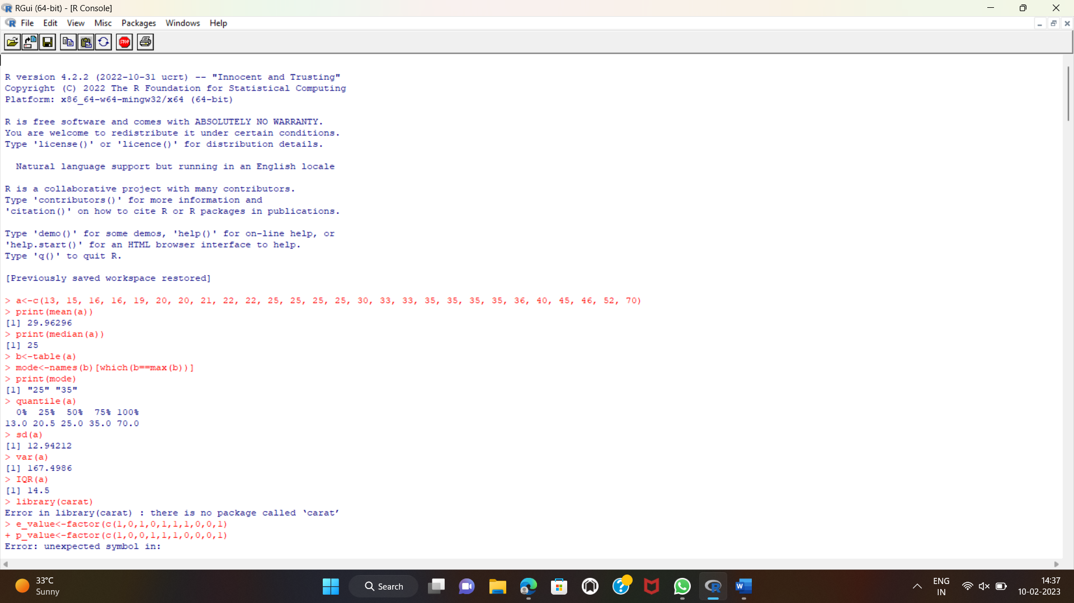

Question 2) Create the Confusion matrix using this scenario: A shepherd boy gets bored tending the town's flock. To have some fun, he cries out, "Wolf!" even though no wolf is in sight. The villagers run to protect the flock, but then get really mad when they realize the boy was playing a joke on them.One night, the shepherd boy sees a real wolf approaching the flock and calls out, "Wolf!" The villagers refuse to be fooled again and stay in their houses. The hungry wolf turns the flock into lamb chops. The town goes hungry. Panic ensues.

library(carat)

expected_value <- factor(c(1,0,1,0,1,1,1,0,0,1))

predicted_value <- factor(c(1,0,0,1,1,1,0,0,0,1))

example <- confusionMatrix(data=predicted_value, reference = expected_value)

example

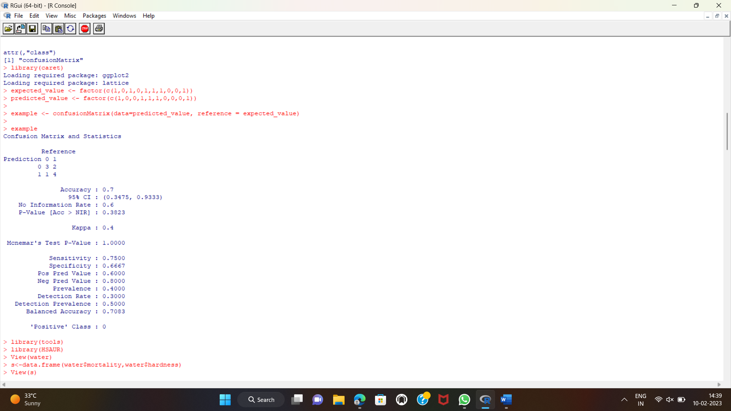

Question 3) Download the Dataset "water" From R dataset Link.Find out whether there is a linear relation between attributes"mortality" and"hardness" by plot function.Fit the Data into the Linear Regression model. Predict the mortality for the hardness=88.

library(tools)

library(HSAUR)

View(water)

s<-data.frame(water$mortality,water$hardness)

View(s)

table(s)

lm(water$mortality~water$hardness)

plot(s)

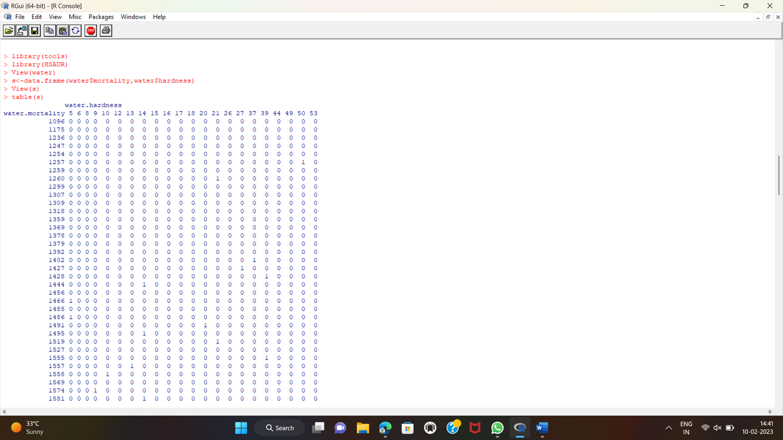

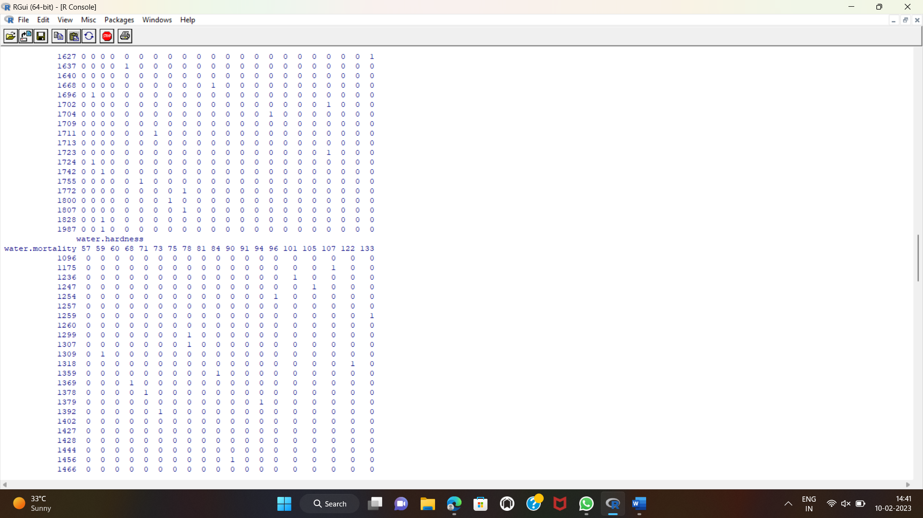

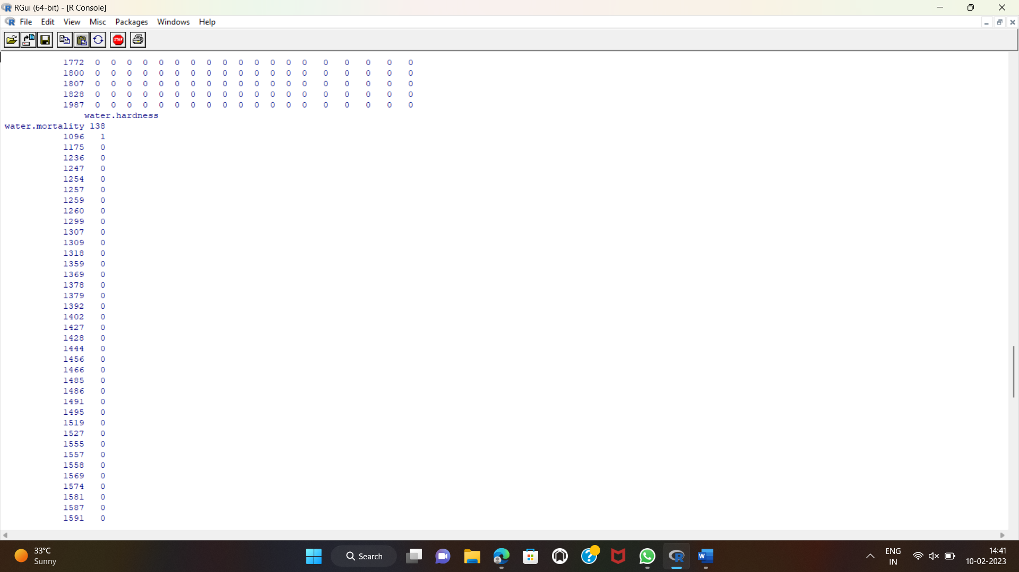

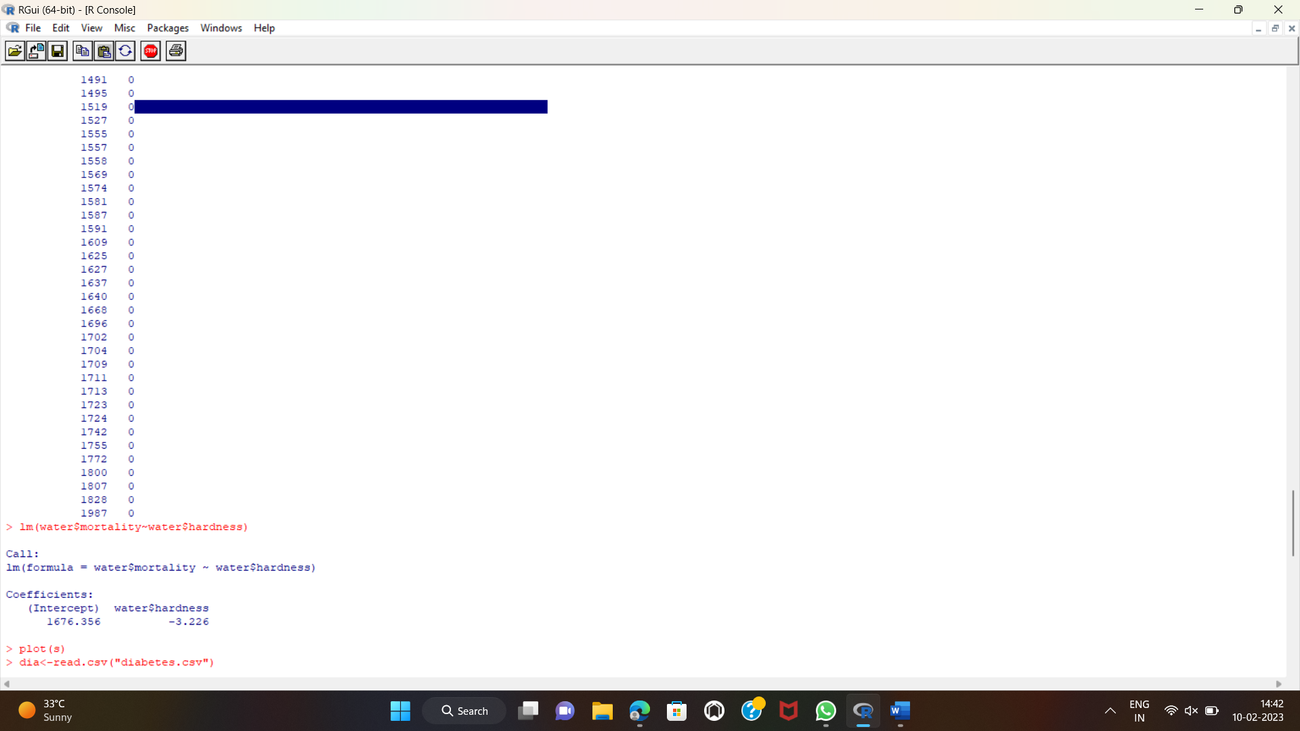

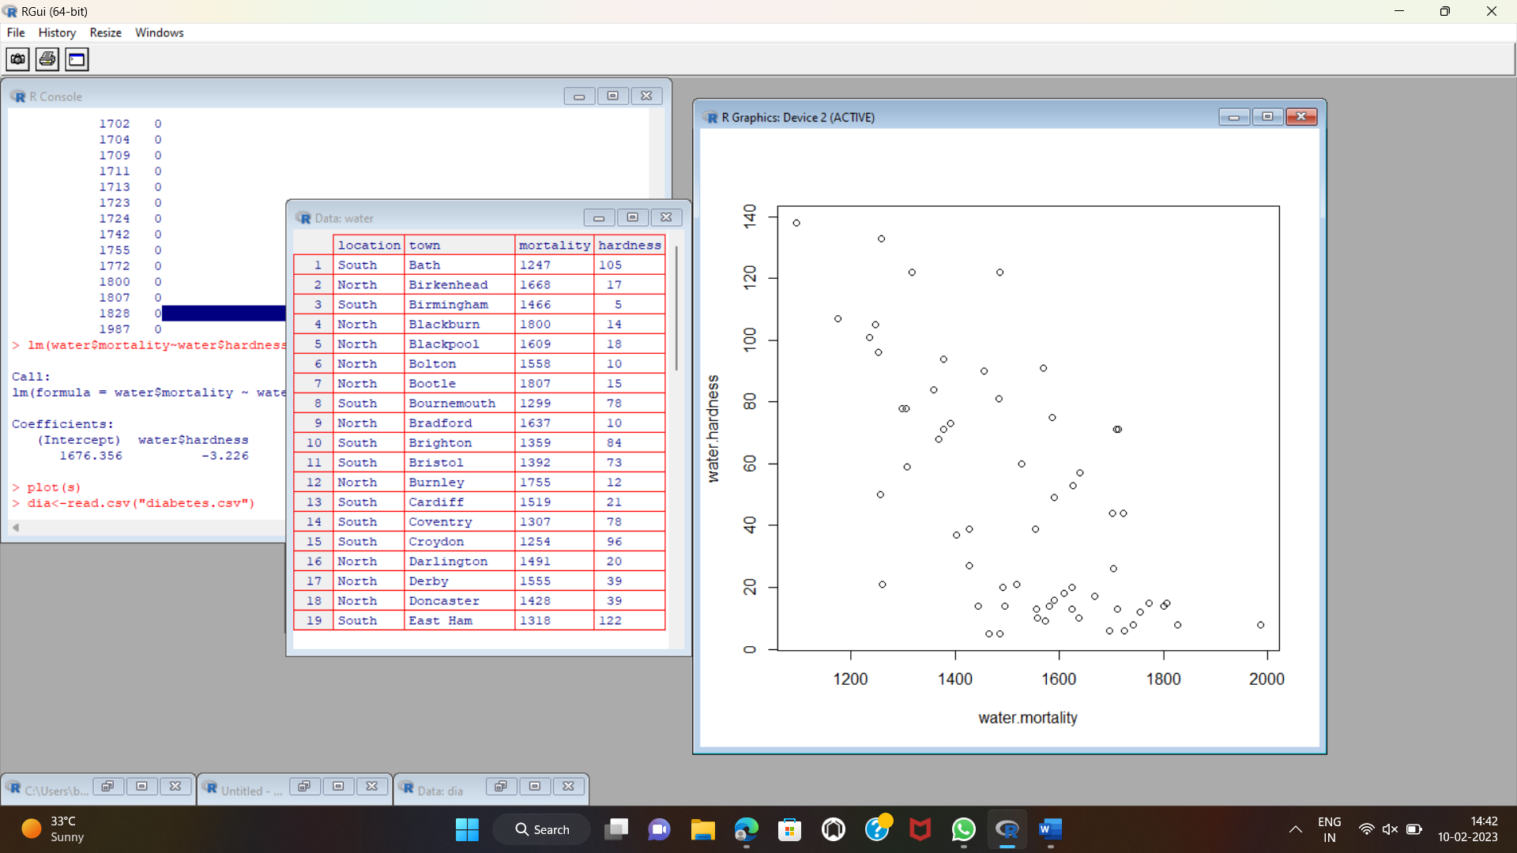

Question 4) Analysis the dataset “diabetes. csv” how the diabetes trend is for different age people, using linear regression and multiple regression.

dia<-read.csv("diabetes.csv")

View(dia)

head(dia)

lm(dia$Pregnancies~dia$Age)

lm(dia$Pregnancies~dia$Age+dia$BloodPressure)

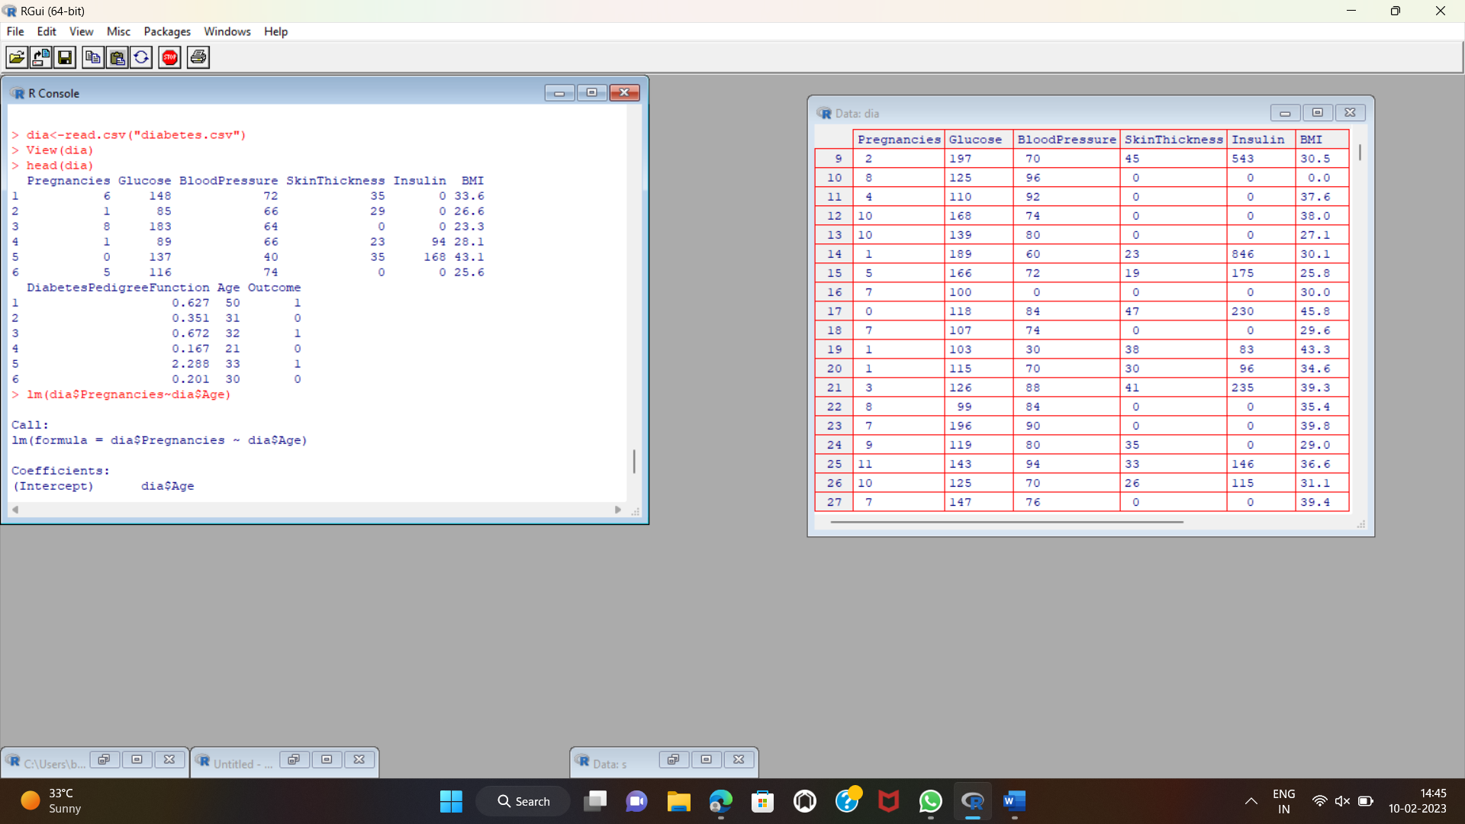

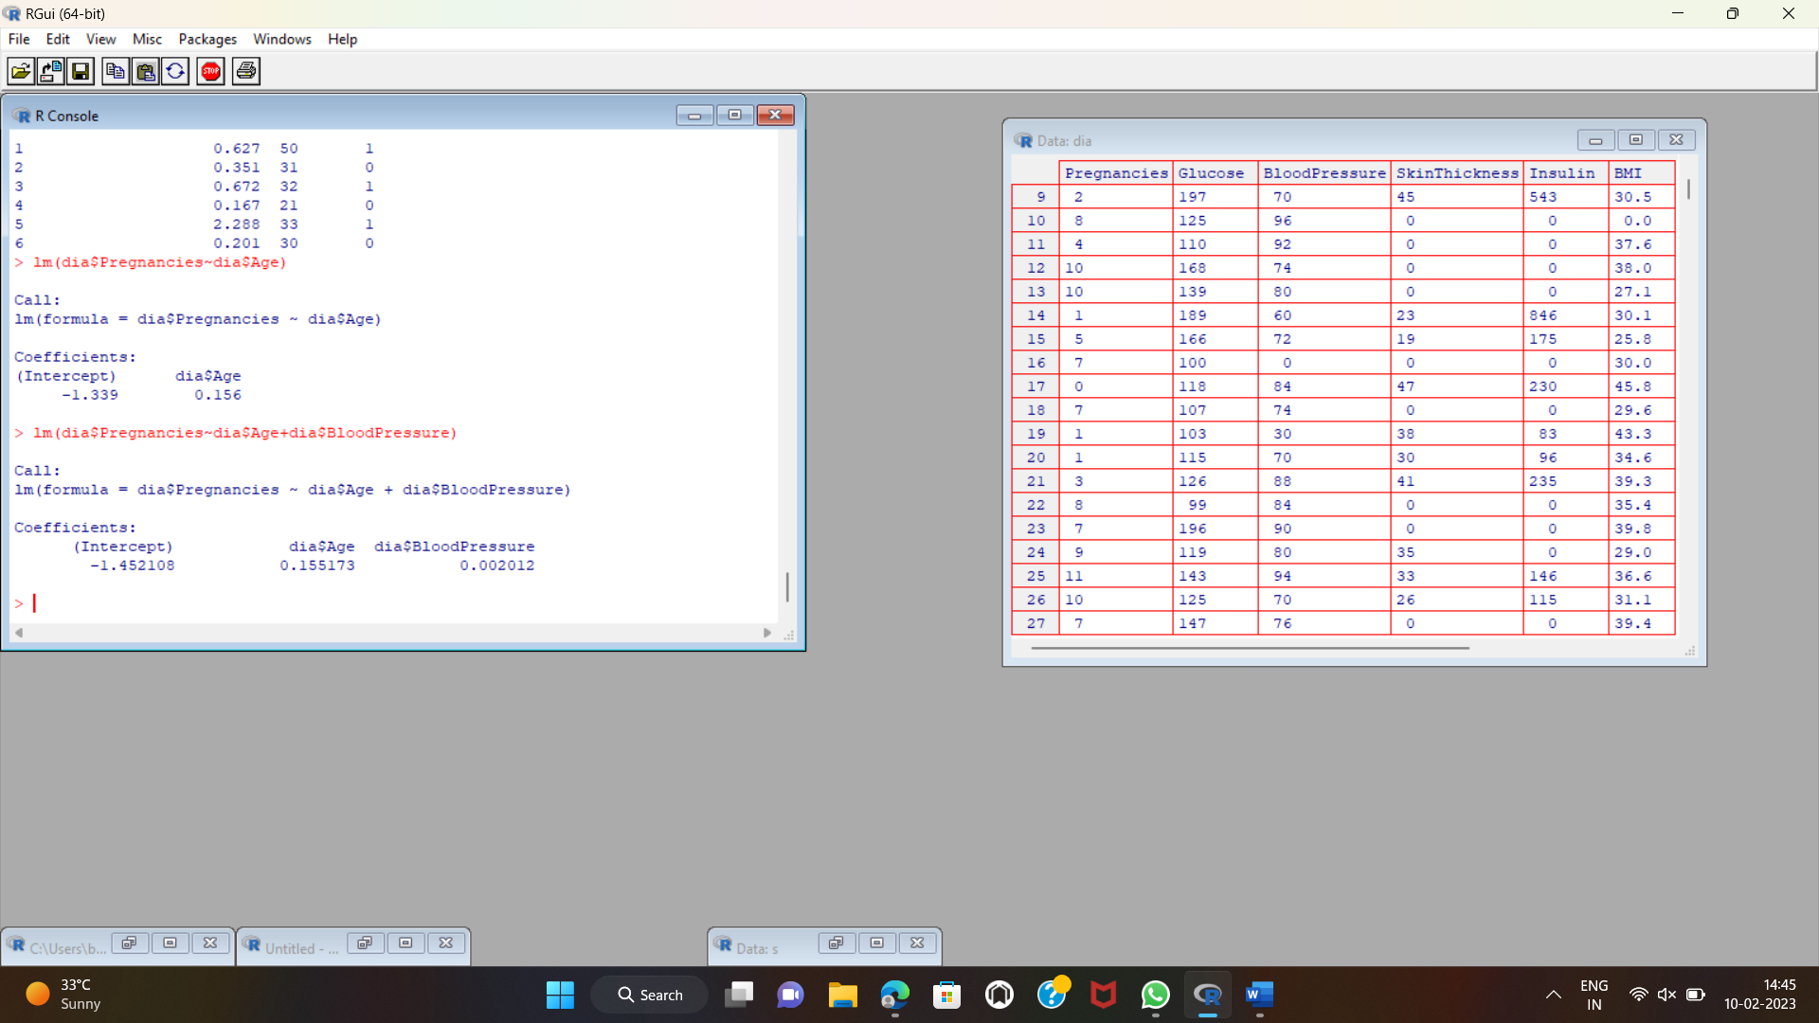

CODES :

